

### Semester One Examination, 2018

### Question/Answer booklet

# Year 11

# MATHEMATICS METHODS

## Section One:

## Calculator Free

**Booklet 1 of 3**

Student name

|  |  |  |  |  |  |
| --- | --- | --- | --- | --- | --- |
| **IFB** | **DD** | **VMU** | **SWA** | **MS** | **AGC** |

**Circle your teacher’s**

**Initials:**

## Time allowed for this section

Reading time before commencing work: five minutes

Working time: fifty minutes

## Materials required/recommended for this section

***To be provided by the supervisor***

This Question/Answer booklet

Formula sheet

***To be provided by the candidate***

Standard items: pens (blue/black preferred), pencils (including coloured), sharpener,  
correction fluid/tape, eraser, ruler, highlighters

Special items: nil

## Important note to candidates

No other items may be taken into the examination room. It is **your** responsibility to ensure that you do not have any unauthorised material. If you have any unauthorised material with you, hand it to the supervisor **before** reading any further.

## Structure of this paper

|  |  |  |  |  |  |
| --- | --- | --- | --- | --- | --- |
| Section | Number of questions available | Number of questions to be answered | Working  time (minutes) | Marks available | Percentage of examination |
| Section One:  Calculator-free | 9 | 9 | 50 | 67 | 35 |
| Section Two:  Calculator-assumed | 13 | 13 | 100 | 84 | 65 |
|  | | |  | **Total** | 100 |

## Instructions to candidates

1. The rules for the conduct of examinations are detailed in the school handbook. Sitting this examination implies that you agree to abide by these rules.

2. Write your answers in this Question/Answer booklet.

3. You must be careful to confine your response to the specific question asked and to follow any instructions that are specified to a particular question.

4. Supplementary pages for the use of planning/continuing your answer to a question  
have been provided at the end of this Question/Answer booklet. If you use these pages to continue an answer, indicate at the original answer where the answer is continued, i.e. give the page number.

5. Show all your working clearly. Your working should be in sufficient detail to allow your answers to be checked readily and for marks to be awarded for reasoning. Incorrect answers given without supporting reasoning cannot be allocated any marks. For any question or part question worth more than two marks, valid working or justification is required to receive full marks. If you repeat any question, ensure that you cancel the answer you do not wish to have marked.

6. It is recommended that you do not use pencil, except in diagrams.

7. The Formula sheet is not to be handed in with your Question/Answer booklet.

Section One: Calculator-free 35% (67 Marks)

This section has**nine (****9)** questions. Answer **all** questions. Write your answers in the spaces provided.

Working time: 50 minutes.

Question 1 (5 marks)

(a) Solve $5\left(2t+1\right)-3\left(t-4\right)=0$ for $t$. (2 marks)

(b) Solve $\begin{matrix}7 \\ \overline{a-5}\end{matrix}-\begin{matrix}3 \\ \overline{4a}\end{matrix}=0$ for $a$. (3 marks)

Question 2 (12 marks)

Solve the following equations.

(a) $6x^{2}=3x$ (2 marks)

(b) $x\left(x+2\right)=24$ (2 marks)

**Question 2 continued**

(c)  (Express your answer in the simplest form.) (4 marks)

(d)  (4 marks)

**Question 3** **(10 marks)**

1. Simplify  (4 marks)

**Question 3 continued.**

(b) Simplify  (2 marks)

(c) Calculate the exact value of  (4 marks)

Question 4 (6 marks)

A function is defined by $f\left(x\right)=\sqrt{3x}$.

(a) Calculate $f(12)$. (1 mark)

(b) State the domain and range of $f(x)$. (2 marks)

(c) Sketch the graph of $y=f(x)$ on the axes below. Indicate key points. (3 marks)

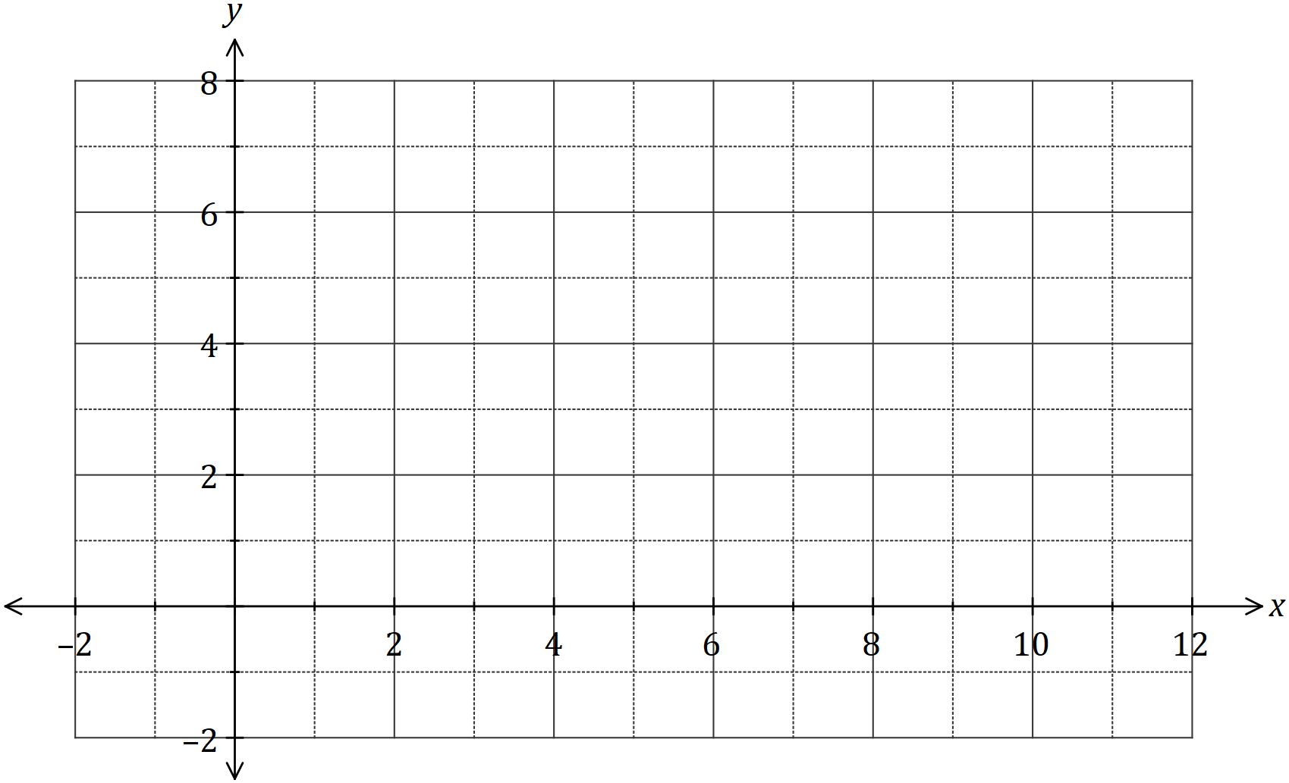

Question 5 (6 marks)

The graph of the line $L_{1}$ is shown below.

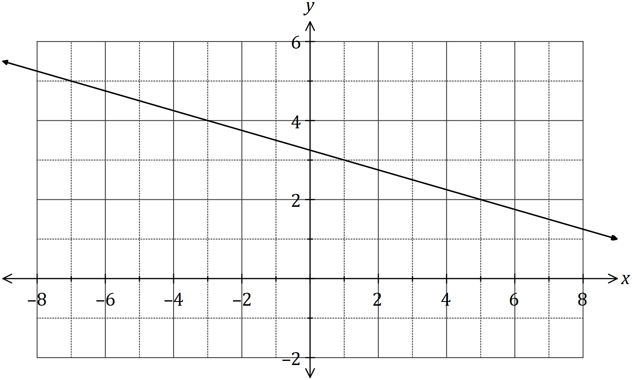

(a) Determine the equation of $L_{1}$. (3 marks)

Two points are located at $A(-10, 5)$ and $B(6, 29)$.

(b) Line $L_{2}$ is perpendicular to $L_{1}$ and passes through the mid-point of $A$ and $B$. Determine the equation of $L_{2}$. (3 marks)

Question 6 (6 marks)

(a) Expand and simplify $(x+2)(2x-5)(x-2)$. (2 marks)

(b) One solution to the equation $x^{3}+36=5x^{2}+12x$ is $x=2$. Determine all other solutions.

(4 marks)

Question 7 (8 marks)

(a) Solve the equation $\sqrt{3}\tan{(x)}-3=0$ for $0≤x≤2π$. (3 marks)

(b) A function has a period of $k$ and is defined by $f\left(x\right)=4\cos{(2x)}$.

(i) State the value of $k$. (1 mark)

(ii) State the amplitude of $f(x)$. (1 mark)

(iii) Sketch the graph of $y=f(x)$ over the domain $-k≤x≤k$. (3 marks)

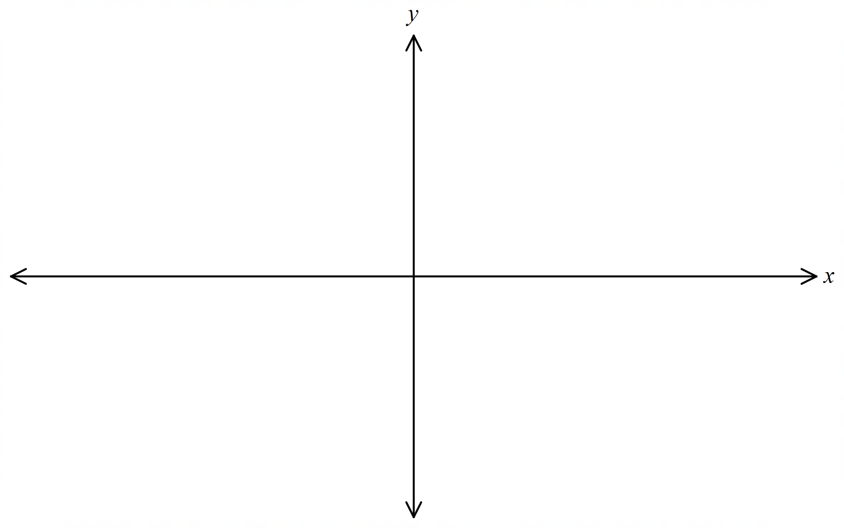

Question 8 (7 marks)

1. Calculate the value(s) of so  has two roots. (4 marks)
2. Calculate the size of the acute angle between the lines: (3 marks)

 and 

Question 9 (7 marks)

(a) The graph of the relation $y^{2}=x$ passes through the points $\left(16,a\right)$ and $(b, -5)$. Determine the values of $a$ and $b$. (3 marks)

(b) Another relation is defined by ${\left(x-1\right)}^{2}+{\left(y+2\right)}^{2}=4$.

(i) Sketch the graph of this relation on the axes below. (3 marks)

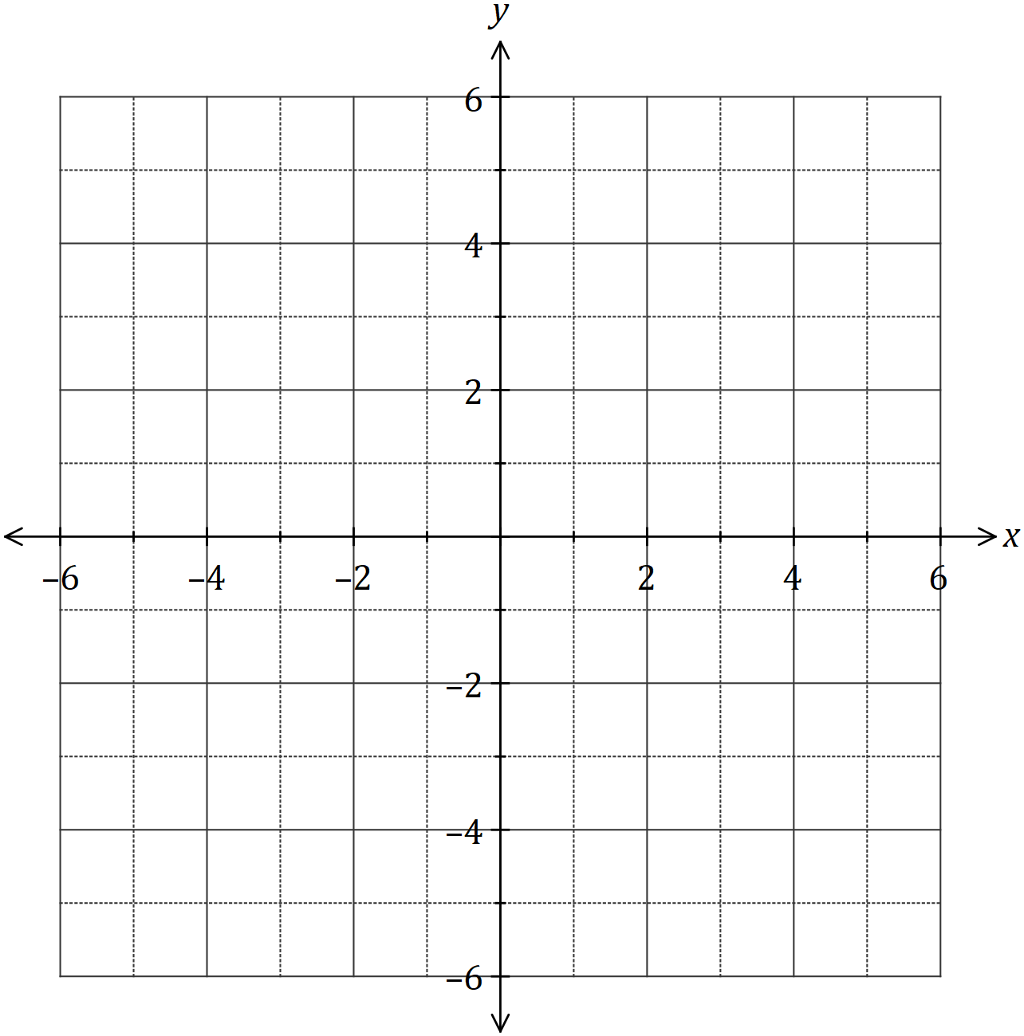

(ii) Provide reasoning why the graph above is of a relation (1 mark)

rather than a function.

End of Questions for Section 1

Supplementary page

Question number: _________

Supplementary page

Question number: _________

© 2018 WA Exam Papers. Hale School has a non-exclusive licence to copy and communicate this document for non-commercial, educational use within the school. No other copying, communication or use is permitted without the express written permission of WA Exam Papers. SN035-112-1.